Advance Database Management System Lab

Experiment- 3

To understand and use SQL Sub-Query

Aryan Mohan

500092142

Batch- 2

create database LAB_Experiment3;

use LAB_Experiment3;

create table Supplier(scode varchar(6) not null, sname varchar(45) not null, scity varchar(50) not null, turnover decimal, primary key(scode));

create table Part(pcode varchar(6) not null, weight int not null, color varchar(30) not null, cost decimal not null, selling_price decimal, primary key(pcode));

create table Supplier_Part(scode varchar(6) not null, pcode varchar(6) not null, qty int not null, primary key(scode, pcode),foreign key(scode) references Supplier(scode), foreign key(pcode) references Part(pcode));

insert into Supplier values ('sup005', 'Amdah', 'San Diego', 1000000.50);

insert into Supplier values('sup001', 'White Stag', 'Delhi', 100000.00);

insert into Supplier values('sup010', 'Whitman', 'Denver', 500000.00 );

insert into Supplier values('sup101', 'Data General', 'Atlanta', 800000.00 );

insert into Part values('p00001', 50.00, 'pink', 10.50, 12.50);

insert into Part values('p00002', 1000.00, 'gray', 20.00, 32.00);

insert into Part values('p00003', 40.00, 'black', 685.00, 700.00);

insert into Part values('p00004', 5000.00, 'black', 450.00, 400.00);

insert into Supplier_Part values ('sup005', 'p00001', 150);

insert into Supplier_Part values('sup001', 'p00002', 500);

insert into Supplier_Part values('sup010', 'p00003', 45 );

insert into Supplier_Part values('sup101', 'p00004', 100 );

--Get the supplier number and part number in ascending order of supplier number.

select scode, pcode from Supplier_Part order by pcode asc;

Output:

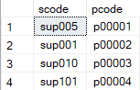

--Get the details of supplier who operate from Bombay with turnover 50.

select * from Supplier where scity='Bombay' and turnover=50;

Output:



--Get the total number of supplier.

select count(scode) from Supplier;

Output:



--Get the part number weighing between 25 and 35.

select pcode from Part where weight between 25 and 35;

Output:



--Get the supplier number whose turnover is null.

select scode from Supplier where turnover is null;

Output:



--Get the part number that cost 20, 30 or 40 rupees.

select pcode from Part where cost=20 or cost=30 or cost=40;

Output:



-- Get the total quantity of part 2 that is supplied.

select sum(qty) from Supplier_Part where pcode= 'p00002';

Output:



--Get the name of supplier who supply part 2.

select * from Supplier select *from Supplier_Part select sname from Supplier, Supplier_Part where Supplier.scode=Supplier_Part.scode and Supplier_Part.pcode='p00002';

Output:

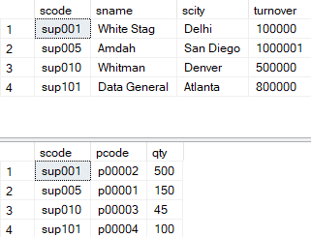

--Get the part number whose cost is greater than the average cost.

select pcode from Part where cost>(select avg(cost) from Part);

Output:



--Get the supplier number and turnover in descending order of turnover.

Select scode, turnover from Supplier order by scode, turnover desc;

Output:

